1. This is the start page

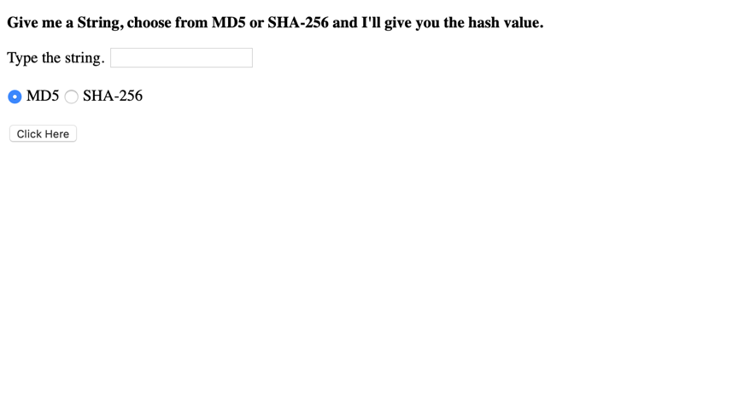

1. If we input “hhh” and don’t click the radio button, the default one is MD5, here is the result

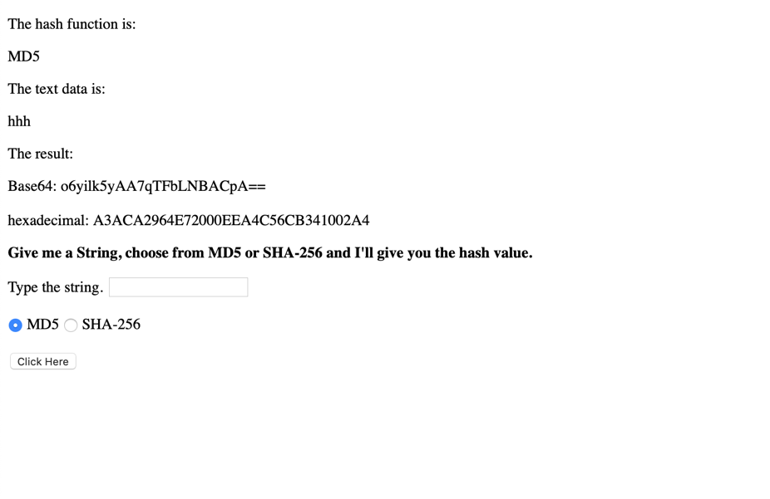

1. If we input “hhh” and click SHA-256, the result will be

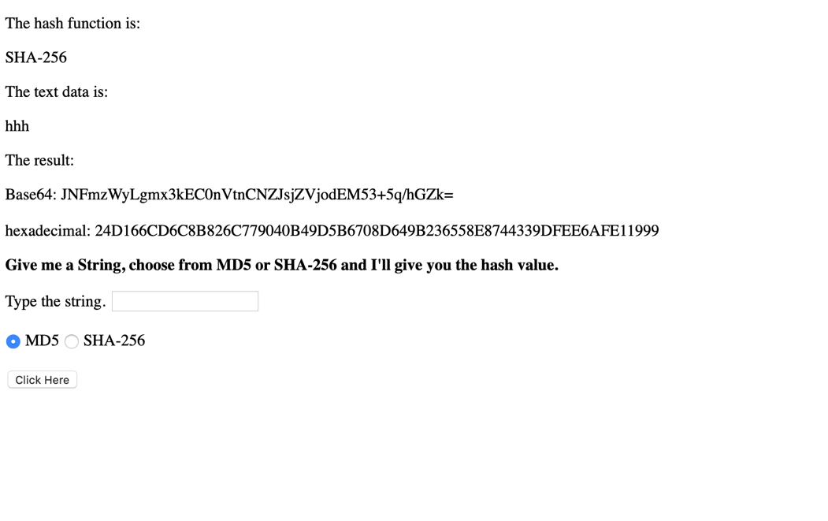

4. This is the start page of the mobile mode

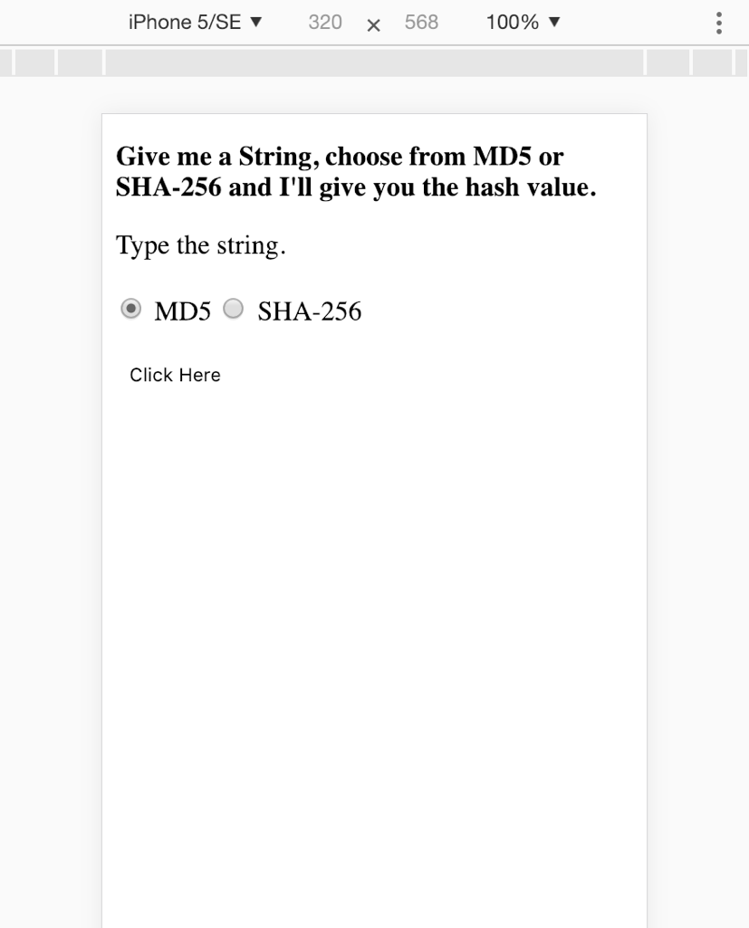

1. If we input “hhh” and choose MD5 in the mobile mode

